ONOS RESTConf Southbound Provider Proposal

Introduction
This document defines the RESTConf Southbound Provider for the ONOS SDN Controller. It defines the high level architecture of the provider which can be used to understand how it is intended to be used, the initial development process, and how to build and integrate the provider.
A key initial design decision that was made is that much of the ONOS NetCONF Southbound provider design, implementation, and toolset(s) should to be replicated or repurposed in the RESTConf provider as much as possible. This will not only allow for faster creation of the driver, but will also greatly increase the possibility that YANG generated code and model drivers may be able to be reused as well with little to no additional work.

History
This project was first conceived of in the summer of 2015. At that time, the first version of ONOS (avocet) had been released and made very successful trade show review at the ONS 2015 conference in Santa Clara. About 3 months prior to this, the Happiest Minds consultancy company from India made a proposal for providing a NetCONF southbound provider and began their initial work. I thought at that time that once the design of RESTConf Southbound Provider would make a good follow-on project and allow me to opportunity to learn the nitty-gritty details of implementing a southbound provider for ONOS.
Initial planning began in early fall of 2015 as the NetCONF project commits to github increased. Then things really started to change. ONOS began to greatly modify their directory structure for providers and it seemed, at least to me, that progress on the NetCONF work had slowed. At this time I decided to hold off work and spend my time working on an ONOS application for a distributed wireless LAN provider. This allowed me to dig into the northbound side of ONOS, the CLI, network configuration subsystem, and the intent framework.
Now it is the summer of 2016 and On.lab and Huawei has picked up the project and is spending significant effort to make the NetCONF Southbound ready for prime time as well as implementing the YANG tools needed by both NetCONF and RESTConf.
It is now my intention to resume development on the RESTConf provider as a fully independent provider that if at all possible, makes full use of the YANG tools and any auto-generated code that the tools create. As mentioned in this documents introduction, 100% reuse of any YANG drivers produced for the NetCONF Southbound is highly desirable.

ONOS Southbound Provider
ONOS interacts with the underlying network with the help of its Providers. Providers in ONOS are standalone ONOS applications based on OSGi components that can be dynamically activated and deactivated at runtime. The main purpose of providers is to abstract the configuration, control and management operations of a specific family of devices (e.g. OpenFlow, SNMP, Netconf, etc.).
Providers offer means to:
- execute requests originated from the core, such as install/get flow rules in OpenFlow, set/get MIB parameters in SNMP, set/get port status in Netconf, etc;
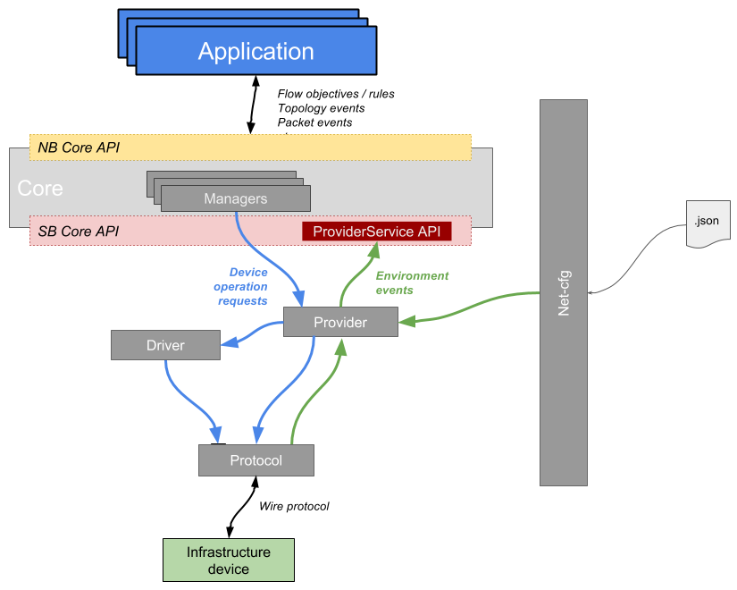
- process and notify the core about events originated from the infrastructure devices or manually injected in the system using the net-cfg service. Examples of environment event that are relevant to ONOS operations are: an OpenFlow switch connection request or packet-in, a BGP route advertisement, a SNMP trap, etc.
Requests from the core are usually originated from the managers (e.g. the DeviceManager, PacketManager, LinkManager, etc.), while providers can notify the core about events using the ProviderService API.
Providers implementation is used to generalize the logic of operating on a device of a given family, when it comes to actually performing a specific operation on a specific device instance, in order to allow support for different flavors of the same device (e.g. different support of the OpenFlow 1.3 specification), providers can call drivers to abstract the device-specific logic. On the other hand, when dealing with external events, a good practice is to have a server or controller component implemented in the protocol module and have providers register for event listeners. Similarly a provider can register for net-cfg events, so that users or external applications can inject information using JSON-formatted messages, such as the IP address and port of the control agent of device, links, and so on.
Usually, there exist multiple providers for the same device family, each one devoted to provide control abstractions and environment sensing over physical and logical infrastructure entities, such as devices, links, flow rules, packets, etc. As an example, the following providers can be defined for the same device family (here the complete list of currently available Provider interfaces in ONOS):
- DeviceProvider: responsible of notifying the core through the DeviceProviderService API about the discovery of new devices and their description (such as vendor/model, available ports, hardware/software version, etc.), as long as exposing method to DeviceManager in order to perform operations such as setting a port operational state (up or down).
- PacketProvider: responsible of notifying the core through the PacketProviderService API of a packet-in event received from the data plane, as long as exposing methods to PacketManager in order to generate packet-outs at the data plane.
- LinkProvider: is responsible of notifying the core through the LinkProviderService API of the discovery of new links, while not methods are exposed to any manager since it would make no sense to perform an operation on a logical entity such as a link.

RESTConf Overview
RESTConf is defined by an IETF RFC Draft (currently at revision 15) that describes an HTTP based protocol for configuring data and obtaining state information on a network element that is defined by a YANG (RFC 6020 & RFC 6241) language model. It is similar in nature to the NETCONF protocol that provides similar features over a secured SSH connection but uses RESTFUL HTTP methods familiar to most WWW and application developers and operates on a single active-config datastore that a device.
A network element that provides a RESTConf interface operates as the RESTConf server and the ONOS RESTConf Southbound provider acts as a RESTConf client. Note that the RESTConf Southbound provider can also subscribe to notifications from the network element and when a notification/alarm is activated, the RESTConf Southbound provider will act as a Server and will translate the notification into an alarm for the ONOS Alarm Manager.

RESTConf SouthBound Provider Design
The RESTConf SB Provider will be split into a separate drivers, protocols, and toolset implementations. This is mirrored in the directory structure as follows:
Directory | Functionality | Notes
…/onos/drivers/restconf | Driver Subsystem | RESTConf device driver specific code.
…/onos/protocols/restconf | SB Protocol Subsystem | RESTConf protocol
…/onos/utils/yangutils | YANG Tools Integration | Hopefully unmodified YANG parsers and java code generation utilities from the NETCONF Southbound Provider

Driver Subsystem
The Driver Subsystem code is primarily responsible for loading specific YANG model drivers for devices that support the RESTConf protocol. The initial review of the NETCONF driver subsystem architecture seems to indicate that it will use a set of XML device specific files that provide a collection of behaviors/capabilities that are supported to provide support for specific operations such as port control, flow rules, and so on.
It is expected that the existing NETCONF logic can be used but minor changes such as referencing a RestconfController or RestconfDevice object will need to be performed.

Driver Configuration Directory & File Structure
TODO: Document directory (build machine and running target) along with XML file structure.

Future Design Work
Once the YANG drivers to support the southbound interface becomes mature in the NETCONF provider, and if the RESTConf provider has similar requirements, then both sets of code could be refactored to use a common library. This will eventually require at least the following NETCONF/RESTConf protocol interfaces to be derived from a common interface:
NETCONF Interface | RESTConf Interface
NetconfController | RestconfController
NetconfDevice | RestconfDevice

Southbound Protocol Subsystem
This section specifies the design of the Southbound Protocol Subsystem for the RESTConf provider. The provider design will be separated into a API/utilities and an implementation submodule/package.

API / Utilities Submodule
The API module provides a set of Java Interfaces that abstract the operations and messages necessary to control a RESTConf device.

DeviceId Syntax
ONOS defines a DeviceId for unique device identification. For the RESTConf provider the DeviceId is a Java URI composed of the follow:
scheme = ‘restconf’
schem-specific-part = ip-address + ‘:’ + port-number
fragment = null
Note that the port number should not be interpreted a specifying either unencrypted (http) or encrypted (https) communications, but instead is a mapping to a specific port to communicate with the device. A system-wide default setting (default is encrypted communications) can be specified as well as a per-device setting. More

Implementation Submodule

TODO: Table of supported operations
TODO: Pictures of logic flow/ operation flow
TODO: Device ID format (separate RestId ???)
TODO: Cluster support / store
TODO: Notifications / Alarm manager integration
TODO: CLI support
TODO: Network Config/JSON support
TODO: system wide http/https setting. Default is https (but use http during debug)
TODO: per-device http/https setting. Default is https.
TODO: Do we want to attempt https and allow fallback to http automatically (system wide and per device)? Redirects may also need to be taken into account when doing initial search for RESTConf root resource.

Future Design Work
TODO: Outline possible work to improve the provider and refactor any of the code to share a common base set of interfaces with the NETCONF SB provider

YANG Tools Integration
TODO: Need to experiment with toolset to determine if this can be easily integrated/supported

Building the Provider

Unit Tests

Installing the provider

References:
ONOS Southbound: Protocols, Providers, Drivers
SDN Tutorials: What is RESTCONF
IETF Network Working Group: RESTCONF Protocol – draft 15

